GitHub Actions CI/CD Project

Knowledge Transfer (KT) Document

AWS ACCOUNT: 767260371307
ASSIGNEE: SANDEEP JAGAN
DEPLOYMENT PLATFORM: AMAZON S3
DOCUMENT VERSION: 1.0
DATE: OCTOBER 2026
1. Introduction
Continuous Integration and Continuous Deployment (CI/CD) are software development practices that automate the process of validating, testing, building, and deploying application code.
This project implements a CI/CD pipeline using GitHub Actions and Amazon Web Services (AWS). The application source code is maintained in GitHub, and GitHub Actions executes the automation workflow whenever the configured repository event occurs.
The pipeline validates the required application files, runs a shell-based test script, prepares the deployment files in a dist/ directory, authenticates to AWS using OpenID Connect (OIDC), and deploys the application files to an Amazon S3 bucket.
AWS Identity and Access Management (IAM) controls the permissions available to the workflow. The OIDC integration enables GitHub Actions to assume an AWS IAM role and obtain temporary credentials instead of relying on long-lived AWS access keys stored in GitHub.
An AWS CodeCommit repository is also configured as an additional repository for maintaining the project source code, workflow, tests, and documentation.
The purpose of this document is to explain the project architecture, implementation, configuration, security controls, testing process, troubleshooting steps, and final verification procedure.
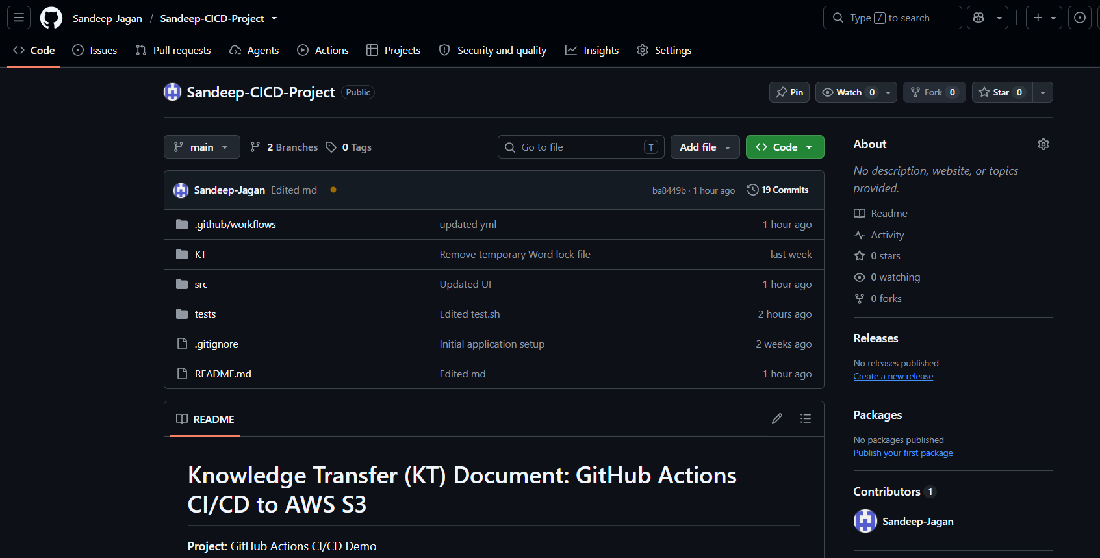
Figure 1: GitHub repository

2. Project Objectives
The primary objectives of the project are:
- Create a GitHub repository for a simple web application.
- Implement an automated CI/CD pipeline using GitHub Actions.
- Validate the application files before deployment.
- Execute automated tests using a shell script.
- Build the application into a deployment-ready directory.
- Configure secure authentication between GitHub Actions and AWS.
- Use GitHub OIDC to assume an AWS IAM role.
- Avoid storing long-lived AWS access keys in the GitHub repository.
- Deploy the application to Amazon S3.
- Configure AWS IAM permissions according to the principle of least privilege.
- Maintain a project repository in AWS CodeCommit.
- Document the implementation, issues encountered, resolutions, and operational procedures.
3. Scope of Work
3.1 Included in the Project
- Static web application developed using HTML, CSS, and JavaScript.
- GitHub source code repository.
- GitHub Actions workflow configuration.
- Shell-based file validation and testing.
- Build process that creates the dist/ directory.
- AWS IAM role and permissions configuration.
- GitHub OIDC integration with AWS STS.
- Automated deployment to an Amazon S3 bucket.
- GitHub repository variables for deployment configuration.
- AWS CodeCommit repository configuration.
- Technical documentation and implementation handover.
4. Technologies Used
Technology | Purpose
Git | Version control and source code management
GitHub | Primary source code repository
GitHub Actions | CI/CD workflow automation
YAML | Workflow configuration format
HTML | Web application structure
CSS | Web application styling
JavaScript | Client-side application functionality
Bash | Validation and testing scripts
AWS IAM | Access management and permissions
AWS STS | Temporary credential issuance through role assumption
GitHub OIDC | Identity federation between GitHub Actions and AWS
Amazon S3 | Static application file storage and deployment destination
AWS CLI | AWS identity verification and S3 synchronization
AWS CodeCommit | Additional Git repository for the project

5. Project Architecture
5.1 Architecture Overview
The project follows a source-to-deployment workflow in which GitHub stores the application and GitHub Actions automates the deployment.
The workflow starts when a configured repository event occurs, such as a push to the main branch.
GitHub Actions validates the source files, runs the tests, prepares the deployment directory, and requests temporary AWS credentials through OIDC role assumption. After authentication succeeds, the workflow deploys the generated files to the configured S3 bucket.

5.2 Architecture Flow
Developer
↓
GitHub Repository
↓
GitHub Actions Workflow
↓
Checkout Source Code
↓
Validate Required Files
↓
Execute Automated Tests
↓
Build Application into dist/
↓
Request GitHub OIDC Token
↓
AWS STS Validates Role-Assumption Request
↓
Assume AWS IAM Deployment Role
↓
Verify AWS Identity
↓
Synchronize Files to Amazon S3
↓
Verify Deployment
AWS CodeCommit is maintained as a separate repository for the project files. GitHub and CodeCommit do not automatically synchronize unless an explicit synchronization mechanism is configured.
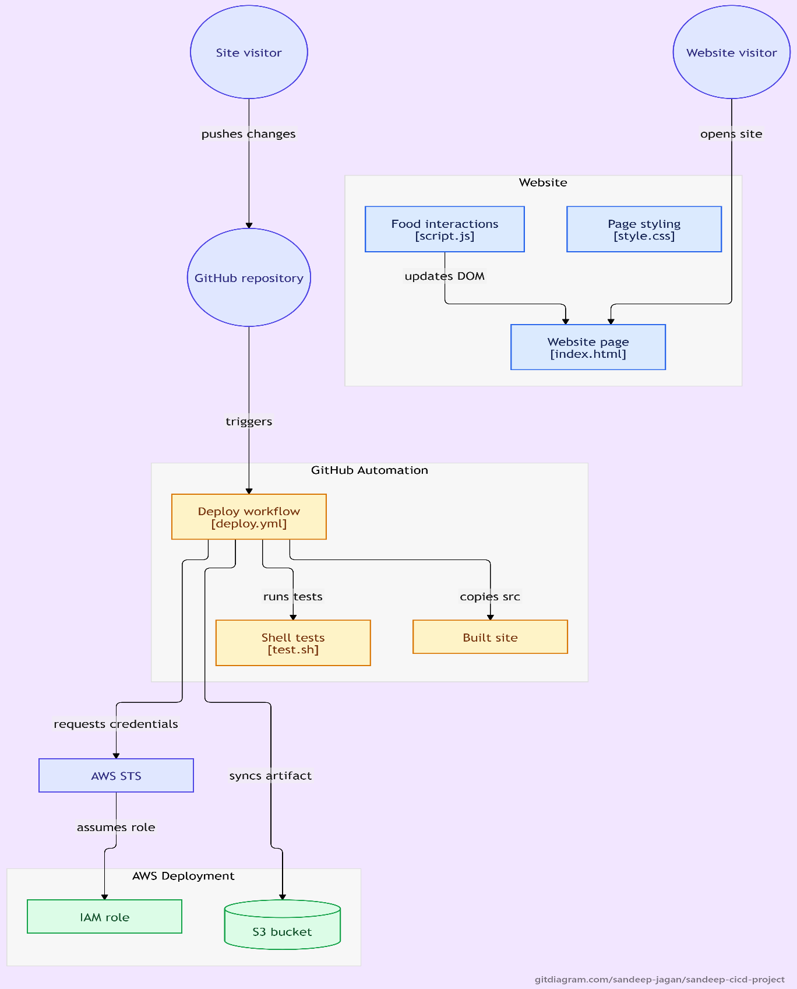
Figure 2: GitHub Actions CI/CD architecture showing the workflow from source code to AWS S3.

5.3 Component Responsibilities
GitHub: Stores application source code, workflow files, tests, and documentation.
GitHub Actions: Executes the CI/CD pipeline.
GitHub OIDC: Provides a signed identity token for the workflow.
AWS STS: Validates the role-assumption request and issues temporary credentials.
AWS IAM role: Defines which AWS permissions the workflow receives.
Amazon S3: Stores the deployed application files.
AWS CodeCommit: Stores an additional copy of the project files when the latest code has been pushed successfully.
6. GitHub Repository Structure
The GitHub repository is: Sandeep-Jagan/Sandeep-CICD-Project
The primary branch is: main
The intended project structure is:
- Sandeep-CICD-Project/
- .github/
  - workflows/
    - deploy.yml
- src/
  - index.html
  - style.css
  - script.js
- tests/
  - test.sh
- KT/
  - GitHub-Actions-CICD-KT.docx
- .gitignore
- README.md
6.1 File Descriptions
File | Description
.github/workflows/deploy.yml | Defines the automated CI/CD workflow
src/index.html | Contains the HTML structure
src/style.css | Contains the application's styles
src/script.js | Contains the client-side JavaScript
tests/test.sh | Executes the project's shell-based tests
KT/GitHub-Actions-CICD-KT.md | Contains the technical KT documentation
.gitignore | Excludes selected local and sensitive files
README.md | Provides project overview and usage instructions

7. Application Overview
7.1 Application Type
The application is a static website developed using HTML, CSS, and JavaScript.
7.2 Application Components
HTML — src/index.html
Defines the page structure and references the required CSS and JavaScript assets.
CSS — src/style.css
Controls the layout, colors, fonts, spacing, and visual presentation.
JavaScript — src/script.js
Provides client-side interactions and application behavior.
7.3 Build Output
The workflow prepares a dist/ directory containing the files required for deployment. The committed workflow is the authoritative source for the exact build commands.
7.4 Deployment Model
After the build succeeds, the workflow synchronizes the contents of dist/ with the configured S3 bucket. This separates the source files from the files intended for deployment and ensures that the deployment step uses the prepared build output.
Figure 4: Static web application running in a browser.

8. GitHub Actions CI/CD Workflow
8.1 Workflow Details
Workflow name: Sandeep Github CI/CD Pipeline
Workflow file: .github/workflows/deploy.yml
The workflow automates validation, testing, build preparation, AWS authentication, and deployment.
8.2 Workflow Permissions
The workflow uses the permissions:
- contents: read
- id-token: write
Permission Explanation
- contents: read - Allows the workflow to read the repository contents required for checkout and validation.
- id-token: write - Allows the workflow to request a GitHub OIDC identity token. This permission is required for OIDC-based AWS role assumption.
These permissions should remain limited to the needs of the workflow.

8.3 Workflow Stages
Stage 1: Checkout Source Code
The workflow checks out the repository using the GitHub Actions checkout action. The source files become available on the runner for subsequent validation and testing.
Stage 2: Validate Required Files
The workflow checks whether required application files exist. This prevents the pipeline from proceeding when important files are missing or incorrectly located.
Stage 3: Run Automated Tests
The workflow executes: bash tests/test.sh
The script performs the checks implemented in the project. These may include file existence and basic content validation. If the script exits with a non-zero status, the workflow should fail and stop before deployment.
Stage 4: Build the Application
The workflow creates the deployment directory and copies the required application files into dist/. This directory becomes the source for the S3 deployment step.
Stage 5: Validate GitHub Variables
The workflow checks that required deployment variables are present before proceeding to AWS authentication.
The required variables are:
- AWS_ROLE_ARN
- AWS_REGION
- S3_BUCKET
Stage 6: Configure AWS Credentials
The workflow uses: aws-actions/configure-aws-credentials@v4
The action requests an OIDC token and uses it to obtain temporary credentials by assuming the configured AWS IAM role. This removes the need to store permanent AWS access keys in GitHub for this deployment.
Stage 7: Verify AWS Identity
The workflow executes: aws sts get-caller-identity
This command displays the identity used by the AWS CLI. It is a useful verification that role assumption succeeded.
Stage 8: Deploy to Amazon S3
The workflow executes: aws s3 sync dist/ "s3://${S3_BUCKET}/" --delete
This synchronizes the build output with the destination bucket. The --delete option removes destination objects that do not exist in the local source directory. It should only be used when the destination is intended to mirror the deployment directory.
8.4 Workflow Success Criteria
The pipeline is considered successful when:
- Checkout completes.
- Required files pass validation.
- The test script succeeds.
- The build directory is prepared.
- Required variables are available.
- AWS role assumption succeeds.
- The AWS identity check succeeds.
- The S3 synchronization completes without errors.
A successful upload does not, by itself, confirm that public website hosting is enabled. Website accessibility must be verified separately.
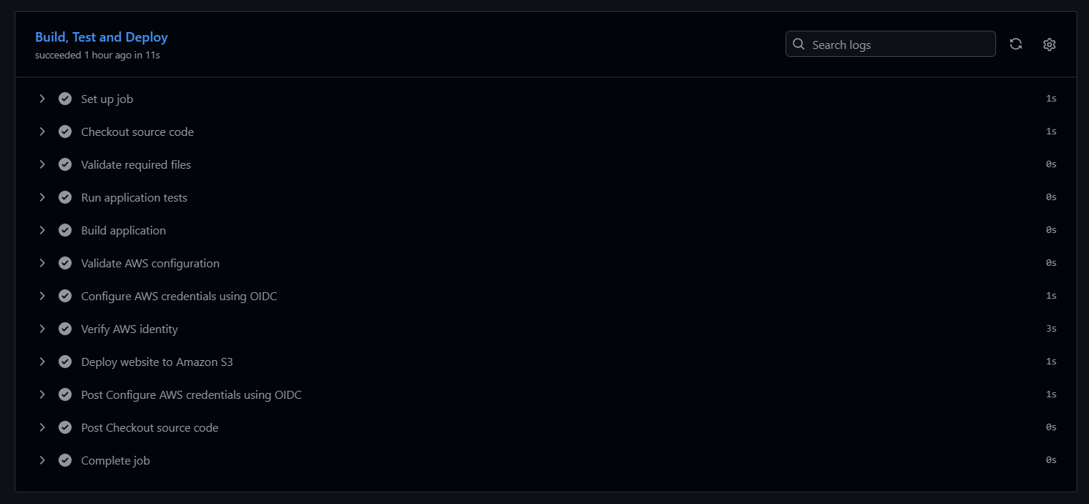Figure 5: GitHub Actions workflow showing successful validation, testing, AWS authentication, and deployment steps.
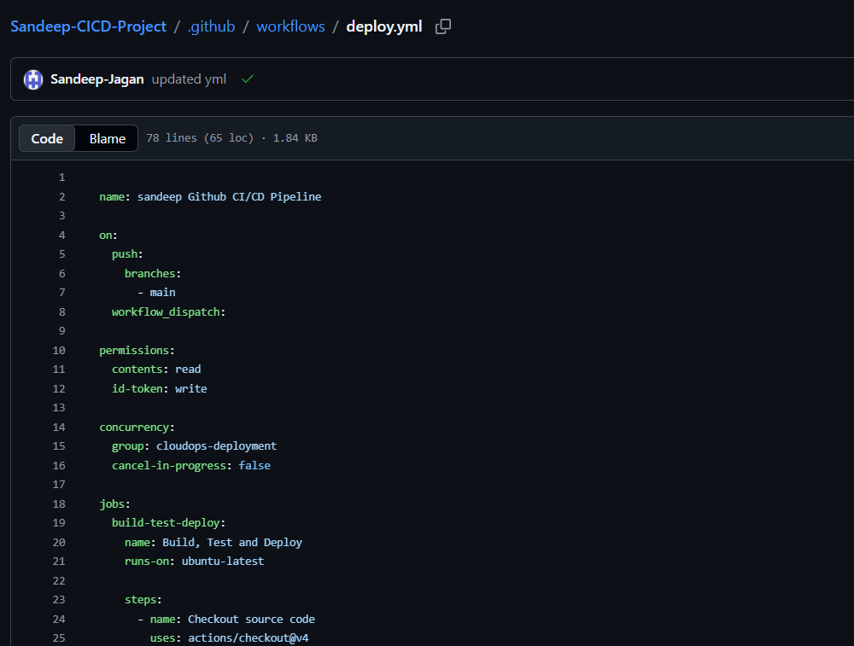Figure 6: Workflow YAML showing the trigger, permissions, tests, AWS authentication, and deployment steps.
9. GitHub Repository Variables
The workflow uses repository variables for environment-specific configuration. These variables contain configuration values, not AWS access keys.
Variable | Configured Value
AWS_ROLE_ARN | arn:aws:iam::767260371307:role/GitHubActions-Sandeep-S3-Deploy
AWS_REGION | us-east-1
S3_BUCKET | githubactions-cicd-demo-sandeep

9.1 Configuration Procedure
- Open the GitHub repository.
- Select Settings.
- Navigate to Secrets and variables → Actions.
- Open the Variables tab.
- Add or update the three variables.
- Save the changes.
- Run the workflow and confirm that the configuration validation succeeds.
9.2 Variable Validation
The values must match the AWS configuration exactly. In particular, the bucket name must not contain leading or trailing spaces. During implementation, the pipeline encountered an invalid bucket-name error caused by a trailing space in the S3_BUCKET variable. The variable was corrected to the exact bucket name, after which deployment succeeded.
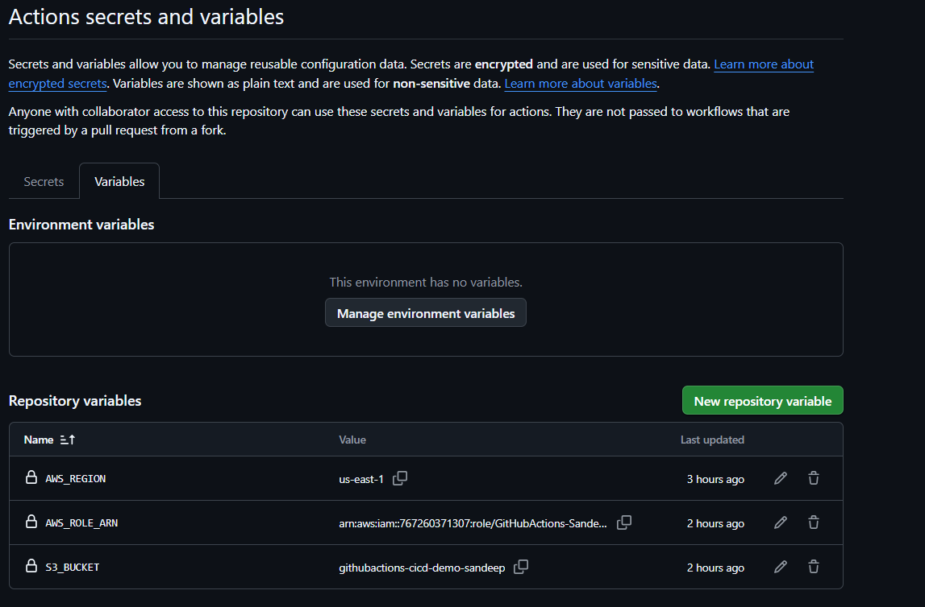Figure 7: GitHub repository variables used by the deployment workflow.

10. AWS Environment Setup
10.1 AWS Environment Details
Resource | Value
AWS Account ID | 767260371307
AWS Region | us-east-1
S3 Bucket | githubactions-cicd-demo-sandeep
IAM Role | GitHubActions-Sandeep-S3-Deploy
IAM Policy | GitHubActions-Sandeep-S3-Policy
CodeCommit Repository | Sandeep-cicd-task-repo

10.2 Amazon S3 Bucket
The S3 bucket stores the static application files produced by the workflow. The bucket name must match the S3_BUCKET GitHub variable. The bucket is the deployment destination and should be dedicated to this application or have a carefully controlled prefix so the --delete operation cannot remove unrelated data.

10.3 IAM Deployment Role
- Role name: GitHubActions-Sandeep-S3-Deploy
- Role ARN: arn:aws:iam::767260371307:role/GitHubActions-Sandeep-S3-Deploy
The role is intended to be assumed by GitHub Actions using OIDC. Its trust policy controls which GitHub workflow identities may assume the role. Its permissions policy controls which AWS operations the assumed role can perform. These are separate controls and both must be configured correctly.
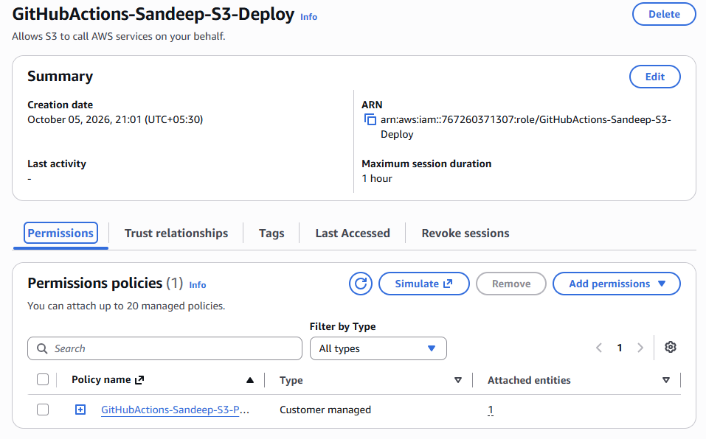Figure 8: AWS IAM role summary showing the deployment role and its ARN.

11. AWS IAM Permissions Policy
11.1 Purpose
The permissions policy controls the AWS actions that are allowed after GitHub Actions assumes the deployment role. For this project, the policy should allow only the S3 operations needed to synchronize the website files. The policy must not grant unnecessary administrative access.
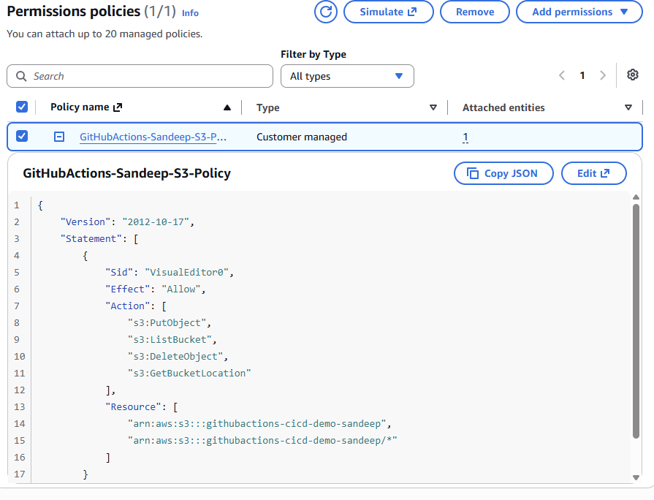Figure 9: IAM permissions policy showing access limited to the project S3 bucket.

12. GitHub OIDC Integration and Trust Policy
12.1 What Is OIDC?
OpenID Connect (OIDC) is an identity protocol that allows GitHub Actions to present a signed identity token to AWS. AWS validates the token and checks whether the identity satisfies the trust conditions configured on the IAM role. When the request is accepted, AWS Security Token Service (STS) provides temporary credentials for the assumed role. This approach avoids storing long-lived AWS access keys in GitHub for the deployment workflow and improves the security of the CI/CD pipeline.

12.2 Steps to Create the GitHub OIDC Identity Provider in AWS
The GitHub OIDC identity provider must be configured in the AWS account before GitHub Actions can authenticate with AWS through OpenID Connect. If the provider already exists, verify its configuration and reuse it instead of creating a duplicate.
Configuration steps:
- Open the IAM service.
- In the left navigation pane, select Identity providers
- Select Add provider
- For Provider type, select OpenID Connect.
- For Provider URL, enter: https://token.actions.githubusercontent.com
- For Audience, enter: sts.amazonaws.com
- Review the values and select Add provider
12.3 OIDC Authentication Flow
- A workflow run starts in GitHub Actions.
- The workflow has id-token: write permission.
- GitHub issues an OIDC token for the workflow.
- The AWS credentials action sends a role-assumption request to AWS STS.
- AWS validates the token and evaluates the role trust policy.
- AWS STS returns temporary credentials if the request is authorized.
- The AWS CLI uses the temporary credentials to verify the identity and deploy the files.
12.4 Trust Policy Purpose
The IAM role trust policy determines which identity can assume the role. It does not define the S3 permissions granted after assumption; those permissions are controlled by the role's permissions policy. The trust policy should be restricted to the intended repository and branch as supported by the actual GitHub OIDC claims and AWS configuration.
12.5 Trust Policy JSON
Insert the exact working trust policy from AWS IAM in this section.
A trust policy normally contains a statement that:
- Allows the federated principal associated with the GitHub OIDC provider.
- Uses the AWS STS AssumeRoleWithWebIdentity action.
- Restricts the audience to sts.amazonaws.com.
- Restricts the subject or equivalent supported claims to the intended GitHub workflow identity.
The precise Condition block must match the working configuration in the AWS console.
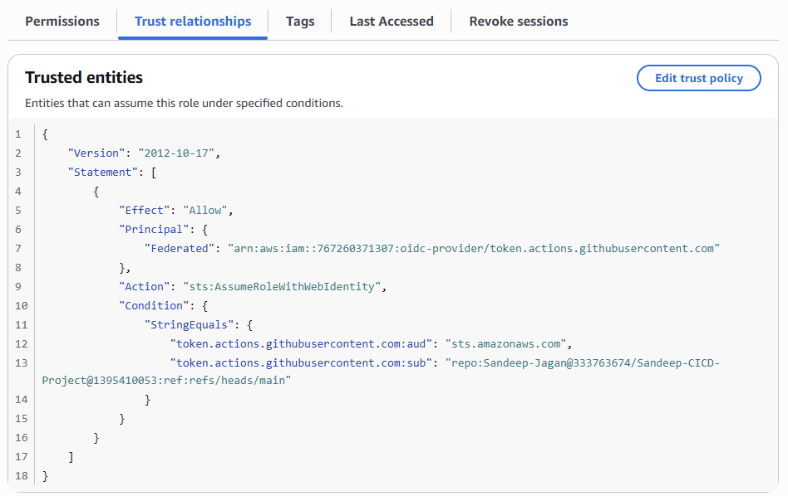Figure 10: AWS IAM trust relationship showing the GitHub OIDC provider and the configured trust conditions.
12.6 OIDC Verification
During verification, the workflow inspected the token's issuer, audience, and subject without printing the token itself.
The output showed:
Issuer: https://token.actions.githubusercontent.com
Audience: sts.amazonaws.com
Subject: repo:Sandeep-Jagan@333763674/Sandeep-CICD-Project@1395410053:ref:refs/heads/main
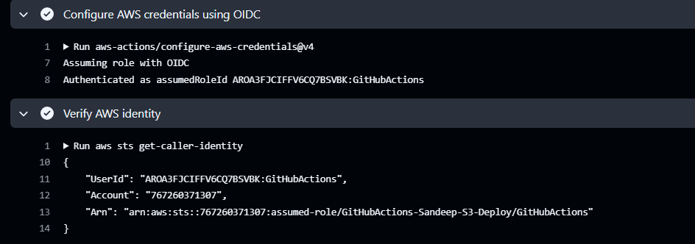Figure 11: GitHub Actions log showing successful AWS identity verification.
13. AWS S3 Deployment
13.1 Deployment Destination
- Bucket: githubactions-cicd-demo-sandeep
- Region: us-east-1
The S3 bucket stores the static website files prepared by the workflow.
13.2 Deployment Command
The workflow uses: aws s3 sync dist/ "s3://${S3_BUCKET}/" --delete
Command Explanation
- aws s3 sync - Compares the local source directory with the S3 destination and synchronizes the files.
- dist/ - The local directory containing the deployment-ready application files.
- s3://${S3_BUCKET}/ - The S3 destination, obtained from the GitHub repository variable.
- --delete - Removes destination objects that are not present in the local source directory.
13.3 Deployment Process
- The workflow builds the application.
- The workflow validates the required AWS configuration.
- GitHub Actions assumes the AWS deployment role.
- The workflow verifies the AWS identity.
- The AWS CLI synchronizes dist/ with the destination bucket.
- The workflow reports success or failure.
13.4 Deployment Verification
After deployment:
- Open the AWS S3 console.
- Navigate to githubactions-cicd-demo-sandeep.
- Verify that index.html, style.css, and script.js are present.
- Check the GitHub Actions deployment step for successful completion.
- Test the website endpoint if website hosting or CloudFront has been configured.
13.5 Deployment Safety
Because the deployment command uses --delete, the destination should be dedicated to the application or the command should be scoped to a safe deployment prefix. Before deploying, verify the bucket variable and confirm that dist/ contains all required files.
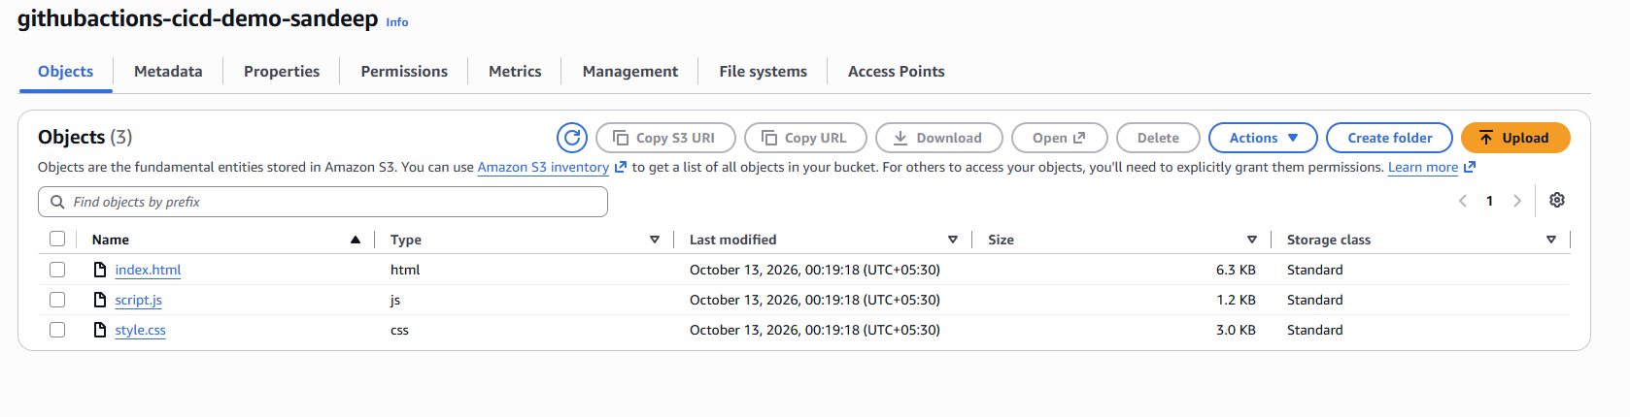Figure 12: S3 bucket showing the deployed application files.
Figure 13: Application accessed through its configured website endpoint

14. Testing and Validation
15.1 Automated Tests
The workflow executes: bash tests/test.sh
The test script performs the checks implemented in the project. The exact test coverage should be described according to the contents of the committed script. If the script checks only file existence and basic content, it should be described as basic validation rather than a comprehensive unit test suite.
15.2 AWS Authentication Test
The workflow executes: aws sts get-caller-identity
This verifies that AWS CLI commands are running under an authenticated AWS identity.
15.3 Deployment Test
The S3 synchronization step verifies that the deployment command completes without reporting an error. Afterward, inspect the S3 bucket to confirm that the expected files were uploaded.
15.4 Expected Results
Test | Expected Result
Required source files exist | Validation passes
Required file is missing | Validation fails
Test script fails | Workflow stops before deployment
GitHub variable is missing | Configuration validation fails
OIDC trust is incorrect | AWS role assumption fails
IAM S3 permissions are insufficient | Deployment fails
S3 synchronization succeeds | Files are synchronized
CodeCommit contains the latest commit | Repository verification passes
Figure 16: GitHub Actions showing successful file validation, tests, and build preparation.
16. Troubleshooting and Issues Resolved
16.1 S3 Bucket Name Error
During deployment, the AWS CLI reported: Invalid bucket name "githubactions-cicd-demo-sandeep "
The bucket name contained an unwanted trailing space.
The correct value was: githubactions-cicd-demo-sandeep
Root Cause - The S3_BUCKET GitHub repository variable did not exactly match the S3 bucket name because of trailing whitespace.
Resolution - The repository variable was corrected to contain the exact bucket name. After the correction, the workflow proceeded through AWS authentication and S3 deployment successfully.
Lesson Learned - Repository variables must be checked carefully for leading or trailing spaces. Configuration values should be validated before running AWS commands.
16.2 OIDC Trust Policy Validation
The workflow's OIDC claims were inspected during troubleshooting. The issuer and audience were as expected, but the reported subject format differed from the common repository subject example. The IAM role trust policy must therefore be checked directly to ensure it matches the actual workflow identity and is restricted to the intended repository and branch. Do not broaden the trust policy unnecessarily to resolve an authentication error.

Resolution and Verification
- Verify the IAM OIDC provider.
- Verify the audience condition.
- Inspect the current trust policy.
- Confirm that the role-assumption step succeeds.
- Remove the temporary diagnostic step if it is no longer required.
16. Security Best Practices
16.1 Use OIDC Instead of Long-Lived AWS Keys - Use the GitHub OIDC integration to assume the deployment role and obtain temporary credentials. Do not hardcode AWS access keys in the repository or workflow.
16.2 Apply Least Privilege - Restrict the role's permissions to the required deployment operations and destination bucket. Avoid broad administrator permissions.
16.3 Restrict the Trust Policy - Restrict role assumption to the intended GitHub identity and branch using the actual supported OIDC claim format. Do not allow unrelated repositories or workflows to assume the deployment role.
16.4 Protect Private SSH Keys - Keep the CodeCommit private key on the authorized machine. Never commit it to GitHub or include it in documentation.
16.5 Protect the S3 Destination - The --delete option can remove objects that are not present in the local deployment directory. Use a dedicated bucket or safe deployment prefix and ensure the IAM role is scoped accordingly.
16.6 Protect Workflow Configuration - Review workflow changes, keep permissions minimal, and consider pinning third-party actions to verified full commit SHAs according to organizational policy.
16.7 Review Workflow Logs - Workflow logs should not contain access keys, secret keys, private keys, or full OIDC tokens.

